Name

Mathematics Stage 4
Percentage Increase, Decrease, and Change

Book 9 | Represent one quantity as a percentage of another with and without the use of digital tools | Version: 260212  Feedback:  https://MrDingMaths.com
Contents
Syllabus Content 2
Converting Percentages to Decimals 3
Finding Percentage of a Quantity 5
Increasing by a Percentage 10
Decreasing by a Percentage 15
Finding Percentage of a Quantity Mentally 20
Increasing and Decreasing by a Percentage Mentally 30
Mixed Practice 32
Financial Applications of Percentage Increase and Decrease 36
Expressing a Quantity as a Percentage of Another 42
Percentage Change 50
Financial Applications of Percentage Change 55

Syllabus Content
MA4-FRC-C-01 represents and operates with fractions, decimals and percentages to solve problems
Represent one quantity as a fraction, decimal or percentage of another
- Represent one quantity as a fraction, decimal or percentage of another by considering appropriate units
- Calculate percentage increases and decreases in various contexts
- Examine the financial applications of percentage increase and decrease, including profit and/or loss as a percentage of cost price or selling price

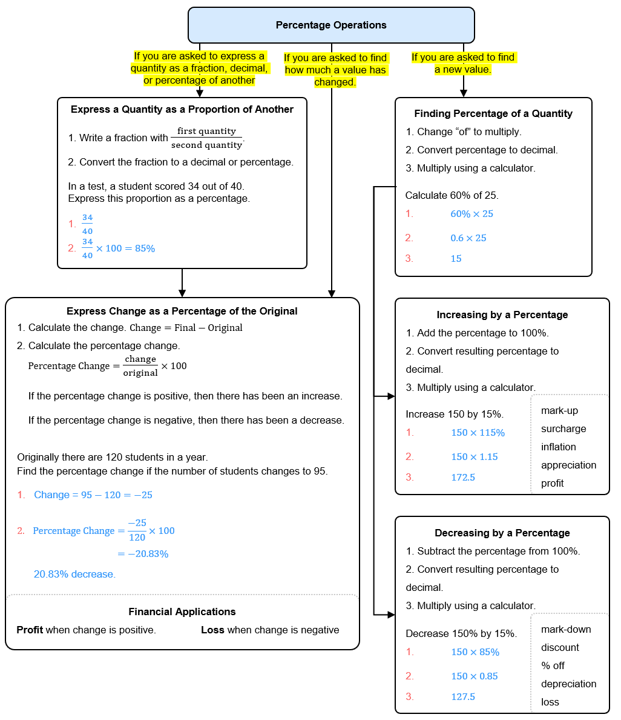

Converting Percentages to Decimals

- Review
- Divide numbers by 100
- $400÷100$ | - $450÷100$ | - $456÷100$
- $45.6÷100$ | - $45÷100$ | - $4.5÷100$
- $4.56÷100$ | - $38÷100$ | - $7÷100$
- $0.7÷100$ | - $125÷100$ | - $12.5÷100$

- Converting Percentages to Decimals
Per cent means “out of 100”
To convert a percentage to a decimal, divide by 100.
Move the decimal point 2 places to the left.

- Convert percentages to decimals
$60\%$  $$=60÷100$$  $$=0.6$$ | $7\%$  $$=7÷100$$  $$=0.07$$ | $125\%$  $$=125÷100$$  $$=1.25$$
Convert the following percentages to a decimal.
- 40% | - 3% | - 150%
- 85% | - 12% | - 200%
- 6% | - 6.5% | - 0.5%

- Key Ideas
- Per cent means out of ……………
- To convert a percentage to a decimal, ………… by …………
- When dividing by 100, the decimal point moves …… places to the ……………

Foundation
- Convert the following percentages to decimals.
- 25%  $$0.25$$ | - 70%  $$0.7$$ | - 9%  $$0.09$$ | - 115%  $$1.15$$
- 4.5%  $$0.045$$ | - 0.8%  $$0.008$$ | - 250%  $$2.5$$ | - 12.5%  $$0.125$$

- Convert the following percentages to decimals.
- 50%  $$0.5$$ | - 5%  $$0.05$$ | - 500%  $$5$$ | - 0.5%  $$0.005$$
- 15%  $$0.15$$ | - 1.5%  $$0.015$$ | - 15.5%  $$0.155$$ | - 155%  $$1.55$$

- Which is larger, the decimal 0.8 or the percentage 8%? Explain your answer.

0.8 is larger. 8% = 0.08, which is less than 0.8
- Convert these to decimals. Remember that 33$\frac{1}{3}\%$ is the same as $\frac{1}{3}$, which is the same as $0.\dot{3}$
- $33\frac{1}{3}\%$  $$0.\dot{3}$$ | - $66\frac{2}{3}\%$  $$0.\dot{6}$$ | - $133\frac{1}{3}\%$  $$1.\dot{3}$$ | - $16\frac{2}{3}\%$  $$0.1\dot{6}$$

- The decimal $0.abc$, where $a,b,c$ are digits, represents what percentage?

$$ab.c\%$$

Finding Percentage of a Quantity

- Review
- Convert percentage to a decimal
- 35% | - 8% | - 120%
- 62% | - 0.6% | - 22.5%

- Multiply decimals using a calculator
- $0.35×250$ | - $0.08×150$ | - $1.2×80$

- The meaning of the word ‘of’
In mathematics, the word ‘of’ means multiply.
When you see 35% of 240, you should think 35% times 250.

The word ‘of’ means ………………
Multiply is what we do when we see the word ……
60% of 15 means 60% ……… 15
$\frac{3}{4}$ of 100 means $\frac{3}{4}$ ……… 100

- Finding Percentage of a Quantity
To find a percentage of a quantity:
            - Change ‘of’ to multiply.
            - Convert the percentage to a decimal. This is called the decimal multiplier.
            - Multiply using a calculator.

- Example Find percentage of a quantity
Find 35% of 240.
1. $=35\%×240$  2. $=0.35×240$  3. $=84$ | We change ‘of’ to $×$ because in mathematics, ‘of’ means ……………………  35% becomes 0.35 because to convert a percentage to a decimal, we divide by ………  The answer 84 is smaller | larger than 240 because 35% is less | more than 100%

- Guided Practice
- 42% of 180  1. = 42% … 180  2.  3. | - 8% of 350  1.  2.  3.
- 115% of 60 | - 6.7% of 450

- Key Ideas
- In mathematics, the word ‘of’ means ………………
- To find a percentage of a quantity, convert the percentage to a ……………… and multiply.
- When the percentage is less than 100%, the answer will be …………… than the original.
- When the percentage is greater than 100%, the answer will be ………… than the original.

Foundation
- Use a calculator to work out the following:
- 37% of 150  $0.37×150=$ …………  55.5 | - 68% of 350  238 | - 9% of 140  12.6
- 12% of 324  38.88 | - 25% of 6.7  1.675 | - 61% of 5  3.05
- 3% of 52  1.56 | - 89% of 137  121.93 | - 8.9% of 137  12.193
- 37% of 820  303.4 | - 29% of 800  232 | - 4% of 650  26
- 16% of 204  32.64 | - 74% of 1800  1332 | - 4.2% of 310  13.02

- A school has 850 students. 64% travel by bus. How many students travel by bus?

544 students
- The human body is around 70% water. A year 10 student weighs around 61 kg.
How much of that is water, in kilograms?

42.7 kg
- Sam scored 87.5% on a test worth 60 marks. How many marks did Sam score?

52.5
- Find 90% of 56 and 9% of 560. What do you notice?

They are equal.

Development
- Jasmine thinks that 2.7% is the same as 0.27. Explain why she is wrong.

2.7% is 0.027
- Find 2.7% of 300  8.1 | - Find 1.8% of 40  0.72

- Use a calculator to work out the following:
- 110% of 20  22 | - 115% of 20  23 | - 185% of 20  37
- 318% of 20  63.6 | - 215.7% of 20  43.14 | - 872.52% of 20  174.504

- Calculate each of the following using a calculator.
- 74% of 765  566.1 | - 47% of 765  359.55 | - 94% of 765  719.1
- 9.4% of 765  71.91 | - 0.94% of 765  7.191 | - 9.04% of 765  69.156
- 904% of 765  6915.6 | - 904.904% of 765  6922.5156 | - $\frac{9}{4}$ $\%$ of 865  19.4625

- In a school of 1000 students, 98% of students attend regularly.
How many students do not attend regularly?

20

- In a survey of 450 people, 38% preferred coffee, 42% preferred tea, and the rest preferred neither. How many people preferred neither?

90 people
- Sven's height is 120% of Huda's height.
Emily's height is 110% of Sven's height.
Huda is 115 cm tall. How tall is Emily?

151.8 cm

  - Which is greater: 15% of 80 or 80% of 15?

They are equal.
  - Explain why $x\%$ of $y$ will also be equal to $y\%$ of $x$.
$$x\% of y=\frac{x}{100}×y=\frac{xy}{100}$$
$$y\% of x=\frac{y}{100}×x=\frac{xy}{100}$$
So, they are equal.

Increasing by a Percentage

- Review
- Find percentage of a quantity.
- 130% of 200 | - 120% of 80 | - 123% of 50

- Add percentages
- 100% + 60% | - 100% + 7% | - 100% + 65%

- Understand 100% of a quantity
- 100% of 50 | - 100% of 85 | - 100% of 21

- Percentage Increase is Finding a Percentage of the Original
When we increase by 20%, we want the original plus 20% extra.
The original is 100%, so we need 100% + 20% = 120% of the original.

Increasing by $x\%$ means finding $\left(100+x\right)\%$ of the original.

- Interpret percentage increase as an increase multiplier
Increasing by 20% means finding 120% of the original | Increasing by 4% means finding 104% of the original | Increasing by 75% means finding 175% of the original.
Identify how much of the original these represent.
- Increasing by 40% means finding  ……… of the original. | - Increasing by 8%  means finding  ……… of the original. | - Increasing by 15%  means finding  ……… of the original.
- Increase by 1.5% means finding  ……… of the original. | - Increasing by 150% means finding  ……… of the original. | - Increasing by 100% means finding  ……… of the original.

- The Decimal Increase Multiplier
To find the increase multiplier as a decimal, add the percentage to 100% and convert this to a decimal. Remember that ‘of’ means multiply.

- Convert percentage increase to decimal increase multiplier
Increase by 20%  = 120% of original  = 1.2 $×$ original | Increase by 7%  = 107% of original  = 1.07 $×$ original | Increase by 45%  = 145% of original  = 1.45 $×$ original
Convert these to the increase multiplier.
- Increase by 30% | - Increase by 9% | - Increase by 12%
- Increase by 1.2% | - Increase by 120% | - Increase by 200%

- Increasing by a Percentage
            - Add the percentage to 100% and multiply by the quantity.
            - Convert the percentage to a decimal.
            - Multiply the quantity by this decimal.

- Example Increase by a percentage
Increase 40 by 35%
1. 135% $×$ 40  2. $= 1.35 × 40$  3. $= 54$ | We add 35% to 100% because we want to keep the original amount (which is ………%) and add ……… more.  135% as a decimal is 1.35 because we divide by …………  The answer is smaller | larger than 40 because we increased.

- Guided Practice
- Increase 125 by 24%  1. ………% $×125$  2. = ……… $×125$  3. = ………… | - Increase 125 by 40%
- Increase 40 by 125% | - Increase 300 by 12.5%

- Key Ideas
- To increase by a percentage, add the percentage to ……………
- Increasing by 20% means finding ………% of the original because we want to keep the ………… and add 20% more.
- Increasing by 20% means multiplying the original quantity by …… (decimal)
- Increasing by 7% means multiplying the original quantity by …… (decimal)

Foundation
- Find the percentage of the original after these increases, and the decimal you would multiply by.
- 10% increase  110%, $×1.1$ | - 15% increase  ……%, $×$……  115%, $×1.15$ | - 35% increase  135%, $×1.35$
- 52% increase  152%, $×1.52$ | - 60% increase  160%, $×1.6$ | - 6% increase  106%, $×1.06$
- 75% increase  175%, $×1.75$ | - 90% increase  190%, $×1.9$ | - 17% increase  117%, $×1.17$

- Calculate these percentage increases.
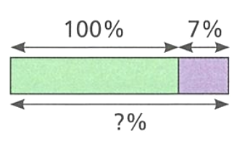  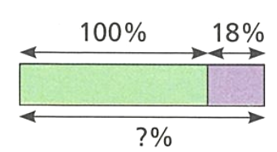  - Increase 200 by 18%  $=$ 200 $×$ 118%  $=$ 200 $×$ 1.18  $=$ …………………  236 | - Increase 80 by 7%  $=$ ……… $×$ ………  $=$ ……… $×$ ………  $=$ …………………  85.6

- Calculate these percentage increases.
- Increase 30 by 10%  $30×1.1=$  33 | - Increase 44 by 2.5%  45.1
- Increase 30 by 20%  36 | - Increase 44 by 5.2%  46.288
- Increase 60 by 20%  72 | - Increase 44 by 5%  46.2
- Increase 60 by 10%  66 | - Increase 44 by 50%  66
- Increase 74 by 10%  81.4 | - Increase 44 by 100%  88
- Increase 74 by 15%  85.1 | - Increase 44 by 150%  110
- Increase 84 by 10%  92.4 | - Increase 44 by 175%  121
- Increase 84 by 5%  88.2 | - Increase 88 by 175%  242
- Increase 84 by 2.5%  86.1 | - Increase 88 by 275%  330

Development
- Jemma’s height increased by 20% since the last time she measured her height.
She was 120 cm tall. How tall is she now?

144 cm
- An arena has a capacity of 2800. An extension increases the capacity of the arena by 35%. Find the new capacity of the arena.

3780
- James earns $850 per week. He receives a 4% pay rise. What is his new weekly wage?

$884

- Zach works 4 days a week. Each working day, he works from 9 a.m. to 4 p.m.
He is paid $20 per hour.
  - How much does he earn for the week?
  - At the end of this week, he is given a 20% bonus on his earnings.
Work out how much Zach earns.

$560 without bonus
$672 with bonus
- The height of a plant increases by 150%.
  - Calculate the new height if the original height was 70 cm.

175 cm
  - Explain why multiplying by 1.5 is incorrect.

To increase, we add 150% to 100%, which is 250%. Therefore, we should multiply by 2.5.

Decreasing by a Percentage

- Review
- Find percentage of a quantity.
- 30% of 200 | - 70% of 80 | - 78% of 50

- Increase by a percentage
- Increase 200 by 25% | - Increase 80 by 10% | - Increase 90 by 0.5%

- Subtract percentages
- 100% $-$ 60% | - 100% $-$ 7% | - 100% $-$ 65%

- Percentage Decrease is Finding a Percentage of the Original
When we decrease by 20%, we want to remove 20% from the original.
The original is 100%, so we need 100% $-$ 20% = 80% of the original.

Decreasing by $x\%$ means finding $\left(100-x\right)\%$ of the original.

- Interpret percentage increase as an increase multiplier
Decreasing by 20% means finding 80% of the original | Decreasing by 4% means finding 96% of the original | Decreasing by 75% means finding 25% of the original.
Identify how much of the original these represent.
- Decreasing by 40% means finding  ……… of the original. | - Decreasing by 8%  means finding  ……… of the original. | - Decreasing by 15%  means finding  ……… of the original.
- Decreasing by 1.5% means finding  ……… of the original. | - Decreasing by 22% means finding  ……… of the original. | - Decreasing by 100% means finding  ……… of the original.

- The Decimal Decrease Multiplier
To find the decrease multiplier as a decimal, subtract the percentage from 100% and convert this to a decimal. Remember that ‘of’ means multiply.

- Convert percentage decrease to decimal decrease multiplier
Decrease by 20%  = 80% of original  = 0.8 $×$ original | Decrease by 7%  = 93% of original  = 0.93 $×$ original | Decrease by 45%  = 55% of original  = 0.55 $×$ original
Convert these to the increase multiplier.
- Decrease by 30% | - Decrease by 9% | - Decrease by 12%
- Decrease by 1.2% | - Decrease by 22% | - Decrease by 90%

- Decreasing by a Percentage
            - Subtract the percentage from 100% and multiply by the quantity.
            - Convert the percentage to a decimal.
            - Multiply the quantity by this decimal.

- Example Decrease by a percentage
Decrease 40 by 25%
1. 75% $×$ 40  2. $= 0.75 × 40$  3. $= 30$ | We subtract 25% from 100% because we want to remove ……% from the original amount (which is ………%).  75% as a decimal is 0.75 because we divide by …………  The answer is smaller | larger than 40 because we decreased.

- Guided Practice
- Decrease 125 by 45%  1. ………% $×125$  2. = ……… $×125$  3. = ………… | - Decrease 125 by 70%
- Decrease 80 by 35% | - Decrease 35 by 80%

- Key Ideas
- To decrease by a percentage, …………… the percentage from 100%
- Decreasing by 20% means multiplying the original quantity by …… (decimal)
- Decreasing by 7% means multiplying the original quantity by …… (decimal)

Foundation
- Find the percentage after these percentage decreases, and the decimal you would multiply by.
- 10% decrease  90%, $×0.9$ | - 15% decrease  ……%, $×$……  85%, $×0.85$ | - 35% decrease  65%, $×0.65$
- 52% decrease  48%, $×0.48$ | - 60% decrease  40%, $×0.4$ | - 6% decrease  94%, $×0.94$
- 75% decrease  25%, $×0.25$ | - 90% decrease  10%, $×0.1$ | - 17% decrease  83%, $×0.83$

- Calculate these percentage decreases.
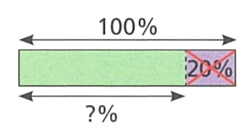  - Decrease 150 by 20%  $=$ 150 $×$ 80%  $=$ ……… $×$ ………  $=$ …………………  120 | 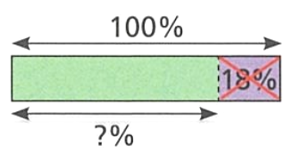  - Decrease 75 by 18%  $=$ ……… $×$ ………  $=$ ……… $×$ ………  $=$ …………………  61.5

- Calculate these percentage decreases.
- Decrease 30 by 10%  $30×0.9=$  27 | - Decrease 68 by 2.5%  66.3
- Decrease 30 by 20%  24 | - Decrease 68 by 5.2%  64.464
- Decrease 60 by 20%  48 | - Decrease 68 by 0.5%  67.66
- Decrease 60 by 10%  54 | - Decrease 48 by 50%  24
- Decrease 74 by 10%  66.6 | - Decrease 48 by 100%  0
- Decrease 74 by 15%  62.9 | - Decrease 96 by 60%  38.4
- Decrease 104 by 10%  93.6 | - Decrease 96 by 30%  67.2
- Decrease 104 by 5%  98.8 | - Decrease 96 by 15%  81.6
- Decrease 104 by 2.5%  101.4 | - Decrease 96 by 10%  86.4

Development
- In 1980, the population of a village was 1200. By 2020, the population had fallen by 45%. Calculate the population of the village in 2020.

660
- A jacket originally costs $85. It is reduced by 40% in a sale. What is the sale price?

$51
- A car is worth $18,000. It loses 12% of its value in one year. What is it worth after one year?

$15 840
- There are 450 students in a year group. 18% are absent one day.
How many students are present?

369 students
- A box of cereal had a mass of 375 g. Over the years the mass has decreased by 22%.
What is its mass now?

292.5 g
- Donald says, ‘prices have gone down by 500%’ Explain why this is impossible.

If you reduce by 500%, then you have $-$400% or $×-4$ of the original.
This means that prices are negative!

Finding Percentage of a Quantity Mentally

- Mental Strategies for Benchmark Percentages
Some percentages are equivalent to simple fractions. These can be calculated mentally by dividing. These mental strategies are shortcuts for specific benchmark percentages only.
Percentage | Fraction | Mental Strategy | Example: 60
50% | $$\frac{1}{2}$$ | divide by 2 | 60 ÷ 2 = 30
$$33.\dot{3}\%$$ | $$\frac{1}{3}$$ | divide by 3 | 60 ÷ 2 = 20
25% | $$\frac{1}{4}$$ | divide by 4 | 60 ÷ 4 = 15
20% | $$\frac{1}{5}$$ | divide by 5 | 60 ÷ 5 = 12
10% | $$\frac{1}{10}$$ | divide by 10 | 60 ÷ 10 = 6
5% | $$\frac{1}{20}$$ | divide by 20 | 60 ÷ 20 = 3
1% | $$\frac{1}{100}$$ | divide by 100 | 60 ÷ 100 = 0.6

- Guided Practice
- Find 50% of 80  $80÷2=$  40 | - Find $33.\dot{3}$% of 300  100 | - Find 25% of 48  12
- Find 20% of 50  10 | - Find 5% of 40  2 | - Find 1% of 90  0.9

- Key Ideas
- 50% is equivalent to the fraction ………, so to find half of something we divide by 2.
- 20% is equivalent to the fraction ………, so we divide by ……

- Deriving New Percentages from Known Percentages
If we know one percentage, we can find other percentages by multiplying, dividing, adding, or subtracting.

- Example Derive new percentage from known percentages
Find 50% of 300  $$300÷2=150$$ |  | Find 10% of 300  $$300÷10=30$$
Find 25% of 300  $$25\%=50\%÷2 \\ =75$$ |  | Find 5% of 300  $$5\%=10\%÷2$$  $$=15$$
Find 75% of 300  $$75\%=50\%+25\%$$  $=225$ |  | Find 2.5% of 300  $$2.5\%=5\%÷2$$  $=7.5$
Find 12.5% of 300  $$12.5\%=25\%÷2$$  $=37.5$ |  | Find 15% of 300  $$15\%=10\%+5\%$$  $$=45$$
Find 1% of 300
$$300÷100=3$$
Find 0.5% of 300
$1\%÷2=1.5$
Find 3.5% of 300
$1\%×3+0.5\%=10.5$

- Guided Practice
- Find 50% of 400  200 |  | - Find 10% of 400  40
- Find 25% of 400  100 |  | - Find 5% of 400  20
- Find 75% of 400  300 |  | - Find 2.5% of 400  10
- Find 12.5% of 400  50 |  | - Find 15% of 400  60
- Find 1% of 400
4
- Find 0.5% of 400
2
- Find 1.5% of 400
6

Foundation
- Find 10% of each amount by finding $\frac{1}{10}$
- 190  19 | - 875  87.5 | - 37.6  3.76 | - 9.25  0.925
- 2700  270 | - 1527.6  152.76 | - 72.58  7.258 | - 0.9218  0.09218
- Find 20% of these numbers by either finding $\frac{1}{5}$, or by finding $\frac{1}{10}$ then multiplying by 2.
- 50  10 | - 125  25 | - 75  15 | - 10.5  2.1
- 45  9 | - 400  80 | - 390  78 | - 72  14.4
- Find 5% of these numbers by either finding $\frac{1}{20}$, or by finding $\frac{1}{10}$ then dividing by 2.
- 80  4 | - 60  3 | - 120  6 | - 700  35
- 160  8 | - 150  7.5 | - 450  22.5 | - 850  42.5

- Complete the table.
Question | Diagram | Strategy | Working
10% of 400 | 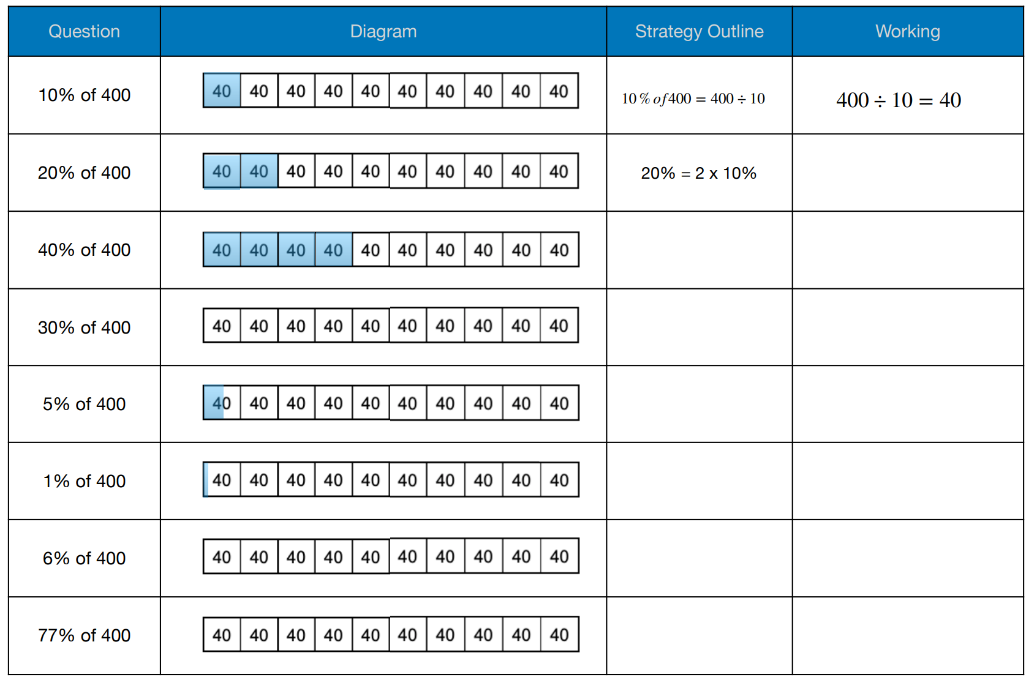 | $$10\%=\frac{1}{10}$$ | $400÷10=$ ………  40
20% of 400 |  | $$20\%=10\%×2$$ | $40×$ …… $=$ ……..  80
40% of 400 |  |  | 160
30% of 400 |  |  | 120
5% of 400 |  |  | 20
1% of 400 |  |  | 4
6% of 400 |  |  | 24

- 10% of 40 =  4 | - 10% of 5 =  0.5
- 10% of 50 =  5 | - 5% of 10 =  0.5
- 50% of 10 =  5 | - 15% of 10 =  1.5
- 50% of 20 =  10 | - 10% of 15 =  1.5
- 20% of 50 =  10 | - 10% of 16 =  1.6
- 10% of 80 =  8 | - 10% of 120 =  12
- 20% of 80 =  16 | - 10% of 100 =  10
- 5% of 80 =  4 | - 100% of 10 =  10
- 10% of 10 =  1 | - 200% of 10 =  20

- Find:
- 10% of 800  80 | - 5% of 800  40
Use your answers above to find:
- 20% of 800  160 | - 15% of 800  120 | - 35% of 800  280
Bethany says:

To find 95% of 800, multiply 10% of 800 by 9, then add on 5%.

Describe a simpler way of finding 95% of 800. (Hint: how could you use 5%?)

Find 5% of 800, then subtract from 800

Development

Find 50% of 120  60 |  | Find 10% of 120  12
Find 25% of 120  30 |  | Find 5% of 120  6
Find 75% of 120  90 |  | Find 2.5% of 120  3
Find 12.5% of 120  15 |  | Find 15% of 120  18
Find 1% of 120
1.2
Find 0.5% of 120
0.6
Find 3% of 120
3.6
Find 3.5% of 120
4.2

Find 20% of 30  6 |  | Find $33.\dot{3}\%$ of 30  10
Find 20% of 15  3 |  | Find $66.\dot{6}$% of 30  20
Find 40% of 15  6 |  | Find $66.\dot{6}$% of 60  40
Find 10% of 15  1.5 |  | Find $66.\dot{6}$% of 180  120
Find 1% of 30
0.3
Find 0.5% of 30
0.15
Find 4% of 30
1.2
Find 8.5% of 30
2.55

- Work these out mentally. ($33\frac{1}{3}\%$ is the same as $33.\dot{3}\%$, which is the same as $\frac{1}{3}$)
- 50% of 8  4 | - 25% of 12  3 | - 75% of 24  18 | - 50% of 30  15
- 25% of 30  7.5 | - 75% of 30  22.5 | - $33$ $\frac{1}{3}$% of 12  4 | - $66$ $\frac{2}{3}$% of 12  8
- $33$ $\frac{1}{3}$% of 27  9 | - $66$ $\frac{2}{3}$% of 30  20 | - $33$ $\frac{1}{3}$% of 90  30 | - $66$ $\frac{2}{3}$% of 180  120
- Work these out mentally.
- 50% of 36  18 | - 20% of 45  9 | - 25% of 68  17
- 25% of 48  12 | - 75% of 48  36 | - 10% of 180  18
- 5% of 80  4 | - 65% of 180  117 | - 45% of 90  40.5
- 10% of 6000  600 | - 1% of 6000  60 | - 3% of 6000  180
- 5% of 60  3 | - 2% of 150  3 | - 30% of 250  75

- Find these amounts mentally:

- 75% of 4.4  3.3 | - 49% of 180  88.2 | - 110% of 6  6.6
- 150% of 50  75 | - 200% of 30  60 | - 120% of 90  108
- $166$ $\frac{2}{3}$% of 120  200 | - 350% of 12  42

- In a survey, 35% of respondents said they felt a penalty was too lenient and 20% felt it was too harsh. If there were 1200 respondents, how many felt the penalty was appropriate?

540
- Eric scored 60% on his most recent Mathematics test. He is determined to improve his score on the next topic test, which will be out of 30 marks. What is the least number of marks Eric can score to improve on his previous test score?

19
- Work out these percentages of 180.
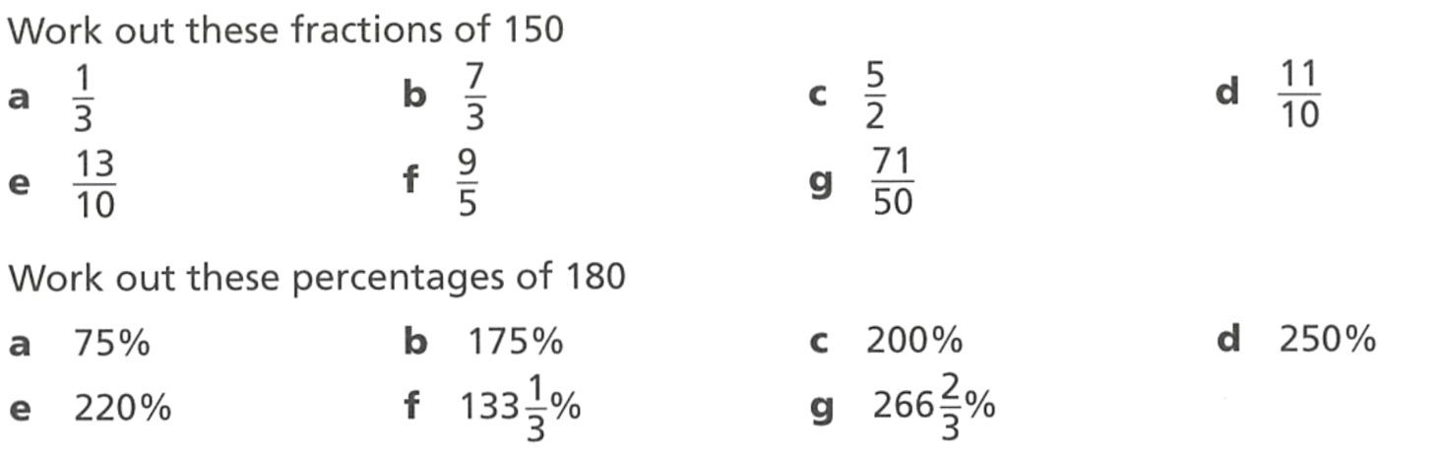  135 | 315 | 360 | 450
396 | 240 | 480

  - Find the difference between 30% of 600 and 33$\frac{1}{3}$% of 600

20
  - Write down 3 $\frac{1}{3}$% of 600

20
  - Work out 3 $\frac{1}{3}$% of 90

3
  - Work out 6 $\frac{2}{3}$% of 450

30

- Work out:
- 30% of 80  24 | - 80% of 30  24
What do you notice about your answers?
They are equal.
Without using a calculator, find:
- 32% of 50  16 | - 16% of 25  4
- 36% of 25  9 | - 17% of 50  8.5
- 64% of 12.5  8 | - 90% of 66 $\frac{2}{3}$  60

- Complete these mentally. Complete the questions going down the columns.
- 50% of 24  12 | - 80% of 50  40 | - 16% of 25  4
- 50% of 72  36 | - 80% of 250  200 | - 18% of 50  9
- 25% of 120  30 | - 80% of 3000  2400 | - 45% of 20  9
- 25% of 480  120 | - 50% of 28  14 | - 20% of 45  9
- 75% of 120  90 | - 28% of 50  14 | - 5% of 64  3.2
- 10% of 90  9 | - 35% of 40  14 | - 15% of 64  9.6
- 10% of 9  0.9 | - 25% of 56  14 | - 8% of 125  10
- 10% of 19  1.9 | - 56% of 25  14 | - 16% of 125  20
- 20% of 55  11 | - 75% of 48  36 | - 116% of 125  145
- 20% of 110  22 | - 75% of 240  180 | - 3% of 120  3.6
- 20% of 165  33 | - 90% of 60  54 | - 103% of 120  123.6
- 40% of 5  2 | - 90% of 15  13.5 | - 10% of 320  32
- 40% of 55  22 | - 70% of 70  49 | - 1% of 320  3.2
- 40% of 155  62 | - 70% of 7  4.9 | - 99% of 320  316.8

Mastery
- Fill in the missing numbers in at least 5 ways.
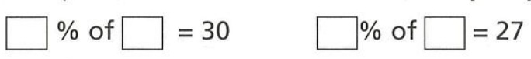

- Work out the following:
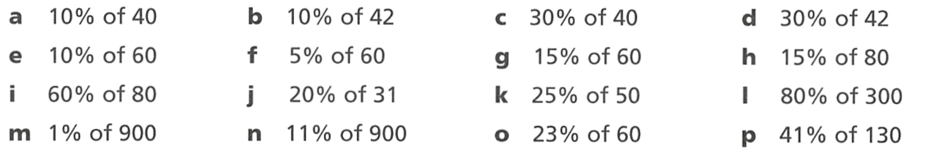  4 | 4.2 | 12 | 12.6
6 | 3 | 9 | 12
48 | 6.2 | 12.5 | 240
9 | 99 | 13.8 | 53.3

- Find the number if:
(hint: convert to fractions)
- 33$\frac{1}{3}$% of the number is 60  180 | - 80% of the number is 60  75
- 75% of the number is 60  80 | - 12.5% of the number is 60  480
- 12% of the number is 60  500 | - 66$\frac{2}{3}$% of the number is 60  90

- In real life, percentages won’t be “nice” numbers that can be easily converted to a common fraction. Instead, you can estimate the whole by rounding.
Worked Solution | Explanation
If 21% is 410, estimate the value of the whole.  $21\%≈20\%$  $\frac{1}{5}$ of a number is 410  $410×5=2050$  So, the whole is around 2050. | What does the $≈$ symbol mean?  Approximately equal to  Why did we choose to round 21% to 20%?  It is the closest baseline percentage  Where did $\frac{1}{5}$ come from?  20% is the same as one fifth  Why did we multiply by 5?  To find the whole from a fifth, we multiply by 5
Without using a calculator, draw a line to match each percentage on the left to the estimate of the whole on the right.
Percentage |  |  |  | Estimate of Whole
- 51% = 72  G |  |  |  | - 10 000
- 97% = 686  D |  |  |  | - 180
- 3% = 298  A |  |  |  | - 1500
- 24% = 103  J |  |  |  | - 700
- 9% = 53  F |  |  |  | - 6000
- 19% = 300  C |  |  |  | - 540
- 33% = 89  I |  |  |  | - 140
- 11% = 612  E |  |  |  | - 80
- 67% = 121  B |  |  |  | - 270
- 74% = 60  H |  |  |  | - 400

Increasing and Decreasing by a Percentage Mentally

- Decreasing by a Percentage
            - Find the percentage of the quantity mentally.
            - Add to the original amount for increase and subtract for decrease.

- Example Increase and decrease by a percentage mentally
Increase 150 by 20%  1. 2$0\%$ of 150  $=150÷5$  $=30$  2. $150+30=180$ | Decrease 80 by 25%  1. 25$\%$ of 80  $=80÷4$  $=20$  2. $80-20=60$

- Guided Practice
- Increase 200 by 25%  1.  2. | - Increase 120 by 10%
- Increase 60 by 5% | - Decrease 250 by 20%
- Decrease 80 by 10% | - Decrease 60 by 1%

Foundation
- Complete the find the increased amounts.
- Increase 400 by 10%  10% of 400: ………………  New amount: $400+$ ……… $=$ …………  440 | - Decrease 200 by 40%  40% of 200: ………………  New amount: $200-$ ……… $=$ …………  120

- Calculate these percentage increases:
- Increase 300 by 10%  330 | - Increase 100 by 40%  140 | - Increase 100 by 25%  125
- Increase 90 by $33.\dot{3}$%  120 | - Increase 68 by 20%  81.6 | - Increase 380 by 50%  570

- Calculate these percentage decreases:
- Decrease 24 by 50%  12 | - Decrease 60 by 10%  54 | - Decrease 50 by 40%  30
- Decrease 90 by 30%  63 | - Decrease 150 by 10%  135 | - Decrease 80 by 25%  60

- Calculate the following:
- Increase 80 by 10%  88 | - Decrease 50 by 60%  20 | - Increase 120 by 20%  144
- Decrease 80 by 20%  64 | - Increase 240 by 15%  276 | - Decrease 15 by 10%  13.5

- Amina thinks that increasing a number by 100% is the same as multiplying the number by 2.
  - Explain why Amina is right.

Increasing by 100% meads adding the entire original amount to itself, which is the same as multiplying by 2.
  - What percentage increase would be the same as multiplying by 3?
200% increase

Mixed Practice

Foundation
- Write down the decimal multiplier you would use to
- Increase by 20%  $×1.2$ | - Decrease by 20%  $×0.8$ | - Increase by 30%  $×1.3$
- Decrease by 30%  $×0.7$ | - Decrease by 90%  $×0.1$ | - Increase by 2%  $×1.02$
- Decrease by 2%  $×0.98$ | - Increase by 17%  $×1.17$ | - Decrease by 17%  $×0.83$
- Increase by 65%  $×1.65$ | - Decrease by 65%  $×0.35$ | - Increase by 100%  $×2$
- Increase by 25%  $×1.25$ | - Decrease by 35%  $×0.65$ | - Decrease by 42%  $×0.58$
- Increase by 4.5%  $×1.045$ | - Increase by 123%  $×2.23$ | - Decrease by 4.5%  $×0.955$

- What is the effect of each of these decimal multipliers?
- 1.04  4% increase | - 0.94  6% decrease | - 1.2  20% increase
- 1.23  23% increase | - 1.08  8% increase | - 0.85  15% decrease
- 1.92  92% increase | - 0.62  38% decrease | - 0.18  82% decrease
- 1.09  9% increase | - 1.67  67% increase | - 2  100% increase
- 2.5  150% increase | - 3.5  250% increase | - 0.1  90% decrease
- 0.05  95% decrease | - 0.02  98% decrease | - 2.02  102% increase

- Evaluate the following:
- Find 30% of 80  $$24$$ | - Increase 50 by 30%  $$65$$ | - Decrease 90 by 30%  $$63$$
- Find 45% of 60  $$27$$ | - Increase 40 by 45%  $$58$$ | - Decrease 120 by 45%  $$66$$
- Decrease 120 by 25%  $$90$$ | - Find 25% of 120  $$30$$ | - Increase 25 by 120%  $$55$$
- Increase 50 by 70%  $$85$$ | - Decrease 350 by 70%  $$105$$ | - 70% of 550  $$385$$
- Increase 160 by 37.5%  $$220$$ | - 37.5% of 320  $$120$$ | - Decrease 200 by 37.5%  $$125$$
- 140% of 60  $$84$$ | - Increase 60 by 140%  $$144$$ | - Decrease 140 by 60%  $$56$$
- Find $33\frac{1}{3}\%$ of 270  $$90$$ | - Decrease 210 by $33\frac{1}{3}\%$  $$140$$ | - Increase 99 by $33\frac{1}{3}\%$  $$132$$
- Increase 400 by 0.5%  $$402$$ | - Decrease 330 by 0.5%  $$328.35$$ | - Find 0.5% of 2000  $$10$$
- Increase 80 by 175%  $$220$$ | - Decrease 85 by 75%  $$21.25$$ | - Find 175% of 190  $$332.5$$

- James has $240. Calculate:
  - 35% of his money
$84
  - How much he has after spending 35%
$156
  - How much he has after receiving an extra 35%
$324
  - How much he has after giving away 65%
$84

Development
- Sophie did these calculations. Identify her errors and give the correct answers:
  - "To find 30% of 50, I multiplied by 1.3 and got 65"

Sophie multiplied by 1.3 (which increases by 30%) instead of 0.3
15
  - "To increase 80 by 25%, I multiplied by 0.25 and got 20"

Sophie found 25% of 80 instead of increasing 80 by 25%. Should multiply by 1.25
100
  - "To decrease 120 by 40%, I multiplied by 0.4 and got 48"

Sophie found 40% of 120 instead of decreasing 120 by 40%. Should multiply by 0.6
72
- What single multiplication gives the same result as:
  - Finding 40% of a number, then adding it to the original?

$$×1.4$$
  - Finding 30% of a number, then subtracting it from the original?

$$×0.7$$
  - Adding 50% more to the original?

$$×1.5$$

- Jimmy used 0.27 as his multiplier when working out a percentage problem.
He must have been working out 27% of an amount.


He must have been working out a 73% decrease.

Explain why they are both correct.

A 73% decrease is $100-73=27\%$ of an amount.

Mastery
- Three friends calculate "reduce 80 by 35%":
Alex: 80 × 0.35 = 28
Beth: 80 × 0.65 = 52
Carla: 80 − (80 × 0.35) = 52
  - Who got the correct answer?
Beth and Carla
  - What did Alex actually calculate?
35% of 80, or a 65% reduction

- Calculate:
- 125% of 64  $$80$$ | - Increase 64 by 125%  $$144$$ | - 25% of 64  $$16$$
- Decrease 64 by 25%  $$48$$ | - Increase 64 by 25%  $$80$$ | - Decrease 64 by 75%  $$16$$
  - What do you notice about some of these answers?
Finding 125% of a number gives the same result as increasing by 25%
Finding 25% of a number gives the same result as decreasing by 75%

- For each statement, determine if it is true or false.
  - ‘Finding 70% of a number gives the same result as decreasing by 30%’
True
  - ‘Increasing by 50% gives the same result as finding 50%’
False
  - ‘Decreasing by 50% gives the same result as finding 50%’
True
  - ‘Finding 120% of a number gives the same result as increasing by 20%’
True
  - ‘Decreasing by 100% always gives zero’
True

- A quantity Q undergoes different operations. Express each result in terms of Q:
- Find 40% of Q  $$0.4Q$$ | - Increase Q by 40%  $$1.4Q$$ | - Decrease Q by 40%  $$0.6Q$$ | - Find 140% of Q  $$1.4Q$$
- Decrease Q by 60%  $$0.4Q$$ | - Increase Q by 140%  $$2.4Q$$ | - Find 60% of Q  $$0,6Q$$

Financial Applications of Percentage Increase and Decrease

- Review
- Increase and decrease by a percentage
- Increase 80 by 25% | - Increase 500 by 12%
- Decrease 120 by 30% | - Decrease 250 by 15%

- Vocabulary for Percentage Increase and Decrease
Percentage Increase  Mark-up, surcharge, inflation,  appreciation, profit | Percentage Decrease  Discount, % off, mark-down,  depreciation, loss

- Identify percentage increase or decrease
Identify whether the following represents a percentage increase or decrease.
- A jacket is discounted by 20%. | - A restaurant has a 20% public holiday surcharge.
- A bottle of fine wine appreciates by 20%. | - A lolly store makes a 20% profit from selling chocolate.
- A car depreciates by 20% over a year. | - A sale has all items 20% off.
- A cupcake store experiences a 20% loss in customers over the year. | - A tourist shop marks up all items by 20%.

- Example Apply percentage increase/decrease to financial contexts
An $860 television is discounted by 25%. Find the discounted price.
$\$860×0.75$  $$=\$645$$ | ‘Discounted’ means percentage ……………  To decrease by a percentage, we ………… the percentage from 100%, then …………… by the decimal.
An $860 television is marked up by 25%. Find the new price.
$\$860×1.25$  $$=\$1075$$ | ‘marked up’ means percentage ……………  To increase by a percentage, we add the percentage to ………%, then multiply by the …………

- Guided Practice
- A café has a 15% holiday surcharge.  A meal normally costs $17, find the holiday cost. | - A $70 jacket is 60% off in a sale.  Find the sale price.
- A car worth $60000 depreciates by 12%. Find its depreciated value. | - A $250 microwave is marked up by 12%. Find the marked-up price.

- Key Ideas
- Mark-up, surcharge, inflation, appreciation, and profit all mean percentage ………………
- Discount, % off, mark-down, depreciation, and loss all mean percentage …………………
- A 25% discount is the same as multiplying by ……………………
- A 10% surcharge is the same as multiplying by ……………………

- Two Types of Questions
Finding the Change  ‘how much was the discount?’  ‘how much did she save?’  ‘how much did it increase by?’  ‘find the amount of depreciation’  Method: Find percentage of original | Finding the Final Amount  ‘find the discounted price’  ‘what is the sale price?’  ‘what is the new price?’  ‘how much is the item worth now?’  Method: use the increase/decrease multiplier

- Example Apply percentage increase/decrease to financial contexts
A $860 TV is discounted by 25%.  Find the discount amount.  $$Discount = 25\% × \$860 \\ = 0.25 × \$860 \\ = \$215$$ | A $860 TV is discounted by 25%.  Find the discounted price.  $$Discounted price = 75\% × \$860 \\ = 0.75 × \$860 \\ = \$645$$

- Guided Practice
- A shop offers 30% off a $5.50 chocolate. Find the discount amount. | - A shop offers 30% off a $5.50 chocolate. Find the discounted price.
- A $250 microwave has been marked up by 12%. Find the mark-up amount. | - A $250 microwave has been marked up by 12%. Find the marked-up price.
- A shop offers 60% off a $70 jacket.  How much discount would you get? | - A shop offers 60% off a $70 jacket. What is the sale price?
- A drink was $8 and inflated by 7%.  How much did the price increase? | - A drink was $8 and inflated by 7%.  What is the new price?

Foundation

- A pair of shoes normally costs $60. In a sale, the price is reduced by 25%.  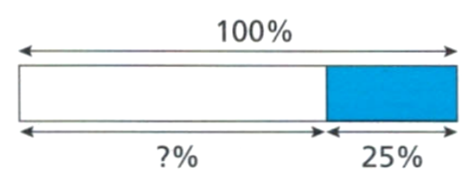  What percentage of the original price is the sale price?  75%  Find the sale price of the shoes.  $45 | 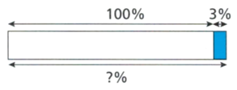  - A train company increases fares by 3%. Lydia used to spend $7 per ticket.  What percentage of the original price is the new price?  103%  Find the new cost of travel.  $7.21
- A toy store is having a sale in which everything is discounted by 10% of the recommended retail price (RRP). A remote-control car has a RRP of $120.
- Calculate the discount on the car.  $12 | - Calculate the selling price of the car.  $108

- A grocery store is increasing all prices by 8%. A tub of ice-cream used to cost $8.50
- Calculate the mark-up.  $0.68 | - Calculate the selling price.  $9.18

- Calculate the new price if:
- $80 is discounted by 50%  $40 | - $30 is marked up by 20%  $36 | - $45 is reduced by 10%  $40.50
- $50 is 65% off  $17.50 | - $75 has a surcharge of 20%  $90 | - $85 appreciates by 120%.  $187
- $450 Blu-ray player reduced by 12%  $396 | - $12 990 second-hand car depreciates by 15%  $11041.50 | - $1 725 000 home with an additional 3% fee  $1 776 750

Development
- A dress costs $42. It is reduced by 15% in a sale. What is the sale price of the dress?

$35.70
- A restaurant has a 1.5% surcharge on all credit card payments.
How much would a $32.50 meal cost if paying by card?

$32.99
- An online clothes store is offering 17.5% off all purchases.
How much would a skirt that originally costs $85 be?

$70.13
- For each of these questions, read carefully to determine what the question is asking for.
- A bicycle was $180 and inflated by 15%. What is the new price?  $$\$207$$ | - A restaurant offers 25% off a $32 meal. Find the discount amount.  $$\$8$$
- A laptop has been marked up by 18%. Find the mark-up amount if the original price was $450.  $$\$81$$ | - A store offers 40% off a $95 pair of shoes. What is the sale price?  $$\$57$$
- A $120 tablet has been marked up by 22%. Find the marked-up price.  $$\$146.40$$ | - A bookshop offers 35% off a $24 novel. How much discount would you get?  $$\$8.40$$
- A phone was $650 and inflated by 8%. How much did the price increase?  $$\$52$$ | - A gym offers 20% off a $180 membership. Find the discounted price.  $$\$144$$

Mastery
- EB Games and Target buy PlayStations at a cost-price of $480 and resell them at a markup.
EB Games has a mark-up of $150 while Target has a mark-up of 25% of the cost-price.
At which store is the PlayStation cheaper, and by how much?

Target cheaper by $30
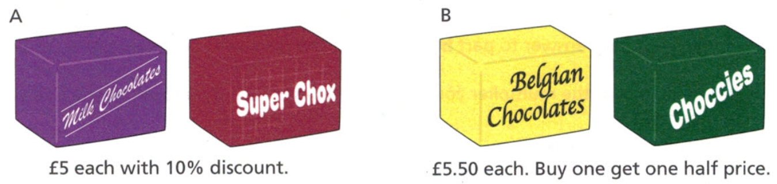
- Emily wants to buy two boxes of chocolate. Which is the better deal, and by how much?

Option B is the better deal by £0.75
- The online retailer Amazon provides three choices for the same TV:
Seller A prices the TV at $2400 but doesn’t offer a discount.
Seller B prices the TV at $2900 but will offer a 20% discount.
Seller C prices the TV at $2750 but will offer a 15% discount.
Which seller offers the TV at the lowest price?

Seller B

- Tammy desperately wants to buy a new mountain bike that has a regular price of $350.
She has only $220. The local bike store regularly has sales with discounts in multiples of 5%.
What is the smallest discount that will allow her to purchase the bike?

40% off
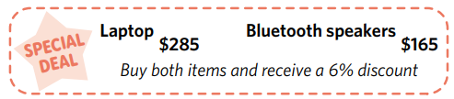
- Ruby buys the laptop and the Bluetooth speakers. The bill is $425.
Is this the correct amount to pay? Explain your answer.

No, she should only have to pay $423

Expressing a Quantity as a Percentage of Another

- Review
- Write as a fraction and simplify, if possible.
- 34 out of 40 students | - 8 out of 20 correct
- $45 out of $60 saved | - $60 out of $45 saved

- Divide using a calculator
- $17÷25$ | - $34÷40$
- $45÷60$ | - $19.5÷20$

- Convert decimals to a percentage
- 0.68 = …………% | - 0.8 = …………%
- 0.05 = …………% | - 0.075 = …………%

- Express a proportion as a fraction, decimal, and percentage.
Diagram | Fraction | Decimal | Percentage
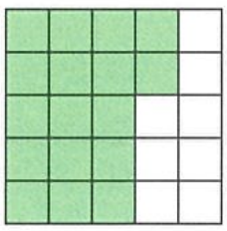

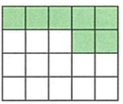

- Expressing a Quantity as a Percentage of Another
To express a quantity $A$ as a percentage of another, $B$:
- Write the fraction $\frac{A}{B}$ $×100$
- Multiply using a calculator.

- Example Express a quantity as a percentage of another
A student scored 34 out of 40 on a test. Express this as a percentage.
1. $\frac{34}{40}$ $×100$  2. $=85\%$ | 34 ‘out of’ 40 written as a fraction is ………  To convert to a percentage, we multiply by …………

- Guided Practice
- A student scored 27 out of 30 on a quiz.  Express this as a percentage.  1. ……… $×100$  2. | - Allison requires $2000 for her trip.  She has saved $1200.  What percentage has she saved?
- In a class of 32 students, 30 completed their homework. What percentage have not completed their homework? | - A student’s height changed from 120 cm to 150 cm.  Express her new height as a percentage of her original height.

- Writing the Fraction
A percentage requires first comparing two quantities $A$ and $B$ by writing them as a fraction: $\frac{A}{B}$
Two rules to help you decide which is $A$ and which is $B$:
The quantity after "of" goes in the denominator (bottom).
The quantity before "as a percentage" goes in the numerator (top).

- Identify numerator and denominator when calculating percentages
- Express 17 as a percentage of 20.  17 goes on top (before ‘as a percentage’)  20 goes on the bottom (after ‘of’)  $$\frac{17}{20}$$ | - Express 20 as a percentage of 17.
- A plant was 40 cm tall and it grew to 60 cm.
Express the new height as a percentage of the original.

- A plant was 80 cm tall and it was cut to 60 cm.
Express the new height as a percentage of the original.

- Jake scored 45 marks. The test was out of 60.
What was Jake’s score as a percentage?

- A test was out of 60 marks. Jake scored 45.
What was Jake’s score as a percentage?

- A shop sold 150 items this week and 75 items last week.
Express this week’s sales as a percentage of last week’s.

- A shop sold 150 items this week and 75 items last week.
Express last week’s sales as a percentage of this week’s.

- A car travels 200 km on Monday and 250 km on Tuesday.
Express Monday's distance as a percentage of Tuesday's.

- A car travels 200 km on Monday and 250 km on Tuesday.
Express Tuesday’s distance as a percentage of Monday’s.

- 35 out of 50 students passed the test.
What percentage did not pass the test?

- Expressing a Quantity as a Percentage of Another (units different)
To express a quantity $A$ as a percentage of another, $B$:
- Express both quantities with the same units.
- Write the fraction $\frac{A}{B}$ $×100$
- Multiply using a calculator.

- Example Express a quantity as a percentage of another
A student has 50 cents. A chocolate at the canteen costs $2.
What percentage of a chocolate does she have?
1. $2 is 200 cents  1. $\frac{50}{200}$ $×100$  2. $=25\%$ | There are ………… cents in $1, so $2 is ………… cents.  We write $\frac{50}{200}$ because …………………… is after "of" so the cost of a whole chocolate goes on the …………  To compare two quantities, the ………… must be the same.

- Guided Practice
- Charlie has 80 cents. A muffin costs $3.50.
What percentage of a muffin does he have?

- For a chemistry lab, Josie needs to measure 2.2 L of water.
She has currently measured 400 mL. What percentage is this?

- From Jenny’s house to the corner shop is 1.3 km. She has walked 450 m.
What percentage of the way there is she?

- Key Ideas
- To express a quantity as a percentage of another, write a …………… then multiply by ……
- The word after ‘of” tells you which quantity is the ………………………… of the fraction.
- The quantity before ‘as a percentage’, is the ………………… of the fraction.
- The units must be the ………… before you do any calculations.

Foundation
- Express these test results as percentages.
- 7 out of 10  $$70\%$$ | - 24 out of 50  $$48\%$$ | - 12 out of 20  $$60\%$$ | - 80 out of 200  $$40\%$$
- 630 out of 1000  $$63\%$$ | - 20 out of 25  $$80\%$$ | - 12 out of 40  $$30\%$$ | - 26 out of 130  $$20\%$$

- Write the shaded parts as a fraction, percentage, and decimal of the whole.
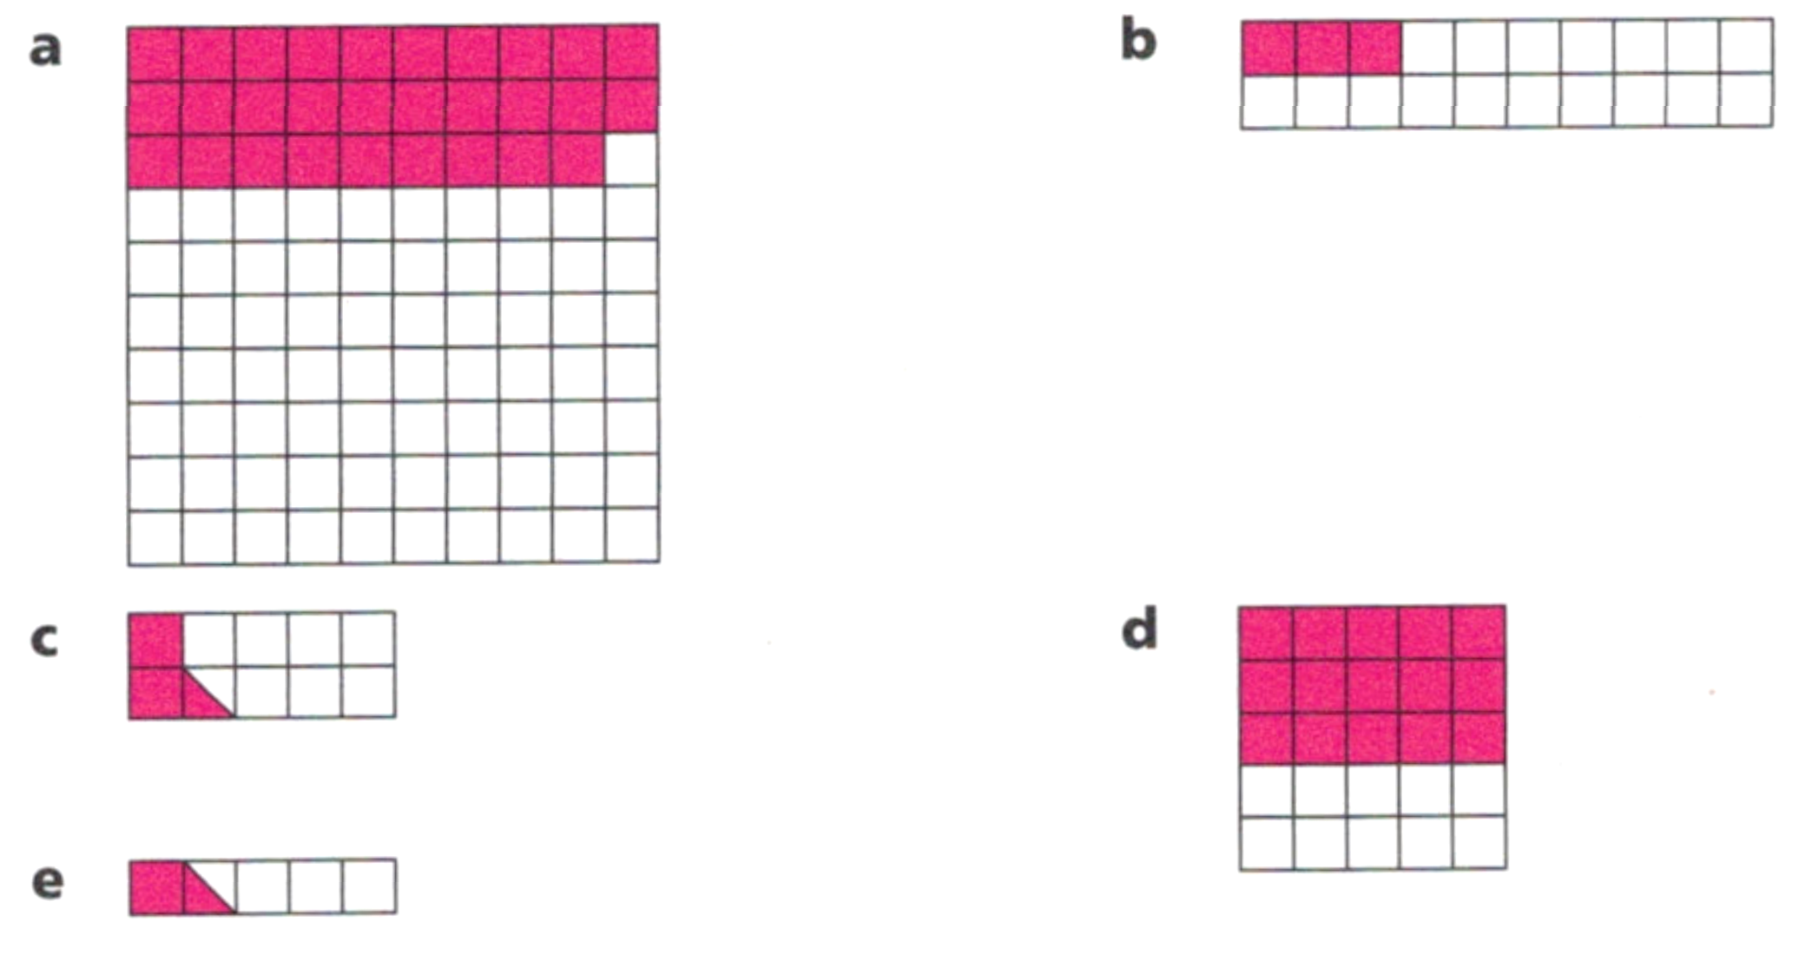
  Fraction | Percentage | Decimal
  $$\frac{3}{20}$$ | $15\%$ | $0.15$
  Fraction | Percentage | Decimal
  $$\frac{15}{25}$$ | $60\%$ | $0.6$
  Fraction | Percentage | Decimal
  $$\frac{3}{10}$$ | $30\%$ | $0.3$
  Fraction | Percentage | Decimal
  $$\frac{1}{4}$$ | $25\%$ | $0.25$

- There are 20 counters on a bag.  14 are blue and the rest are red.  What fraction of the counters are blue?  $$\frac{7}{10}$$  What percentage of the counters are blue?  70% | - At a school, 144 of the 240 year eight students are girls.  What fraction of the students are girls?  $$\frac{3}{5}$$  What percentage of the students are girls?  60%
- Abi has written 350 words of a 500-word essay. What percentage of the whole essay has she written?  70% | - Claire’s goal is to raise $1000 for charity. She managed to raise $1320.  What percentage of her goal did she reach?  132%
- Express these proportions as a percentage.
- 5 out of 20  25% | - 50 out of 400  12.5%
- 50 out of 200  25% | - 150 out of 400  37.5%
- 150 out of 200  75% | - 15 out of 400  3.75%
- 15 out of 20  75% | - 15 out of 40  37.5%
- 5 out of 40  12.5% | - 150 out of 40  375%

- Express these proportions as a percentage. You will need to convert to the same units.
- 40 cents out of $8  5% | - 8 km out of 200 m  4000%
- 50 cents out of $2  25% | - 1.44 m out of 48 cm  300%
- 3 mm out of 6 cm  5% | - 50 cents out of $1  50%
- 400 m out of 1.6 km  25% | - $1 out of 50 cents  200%
- 200 g out of 5 kg  4% | - $5.10 out of 85 cents  600%

- Express 60 as a percentage of 240 | 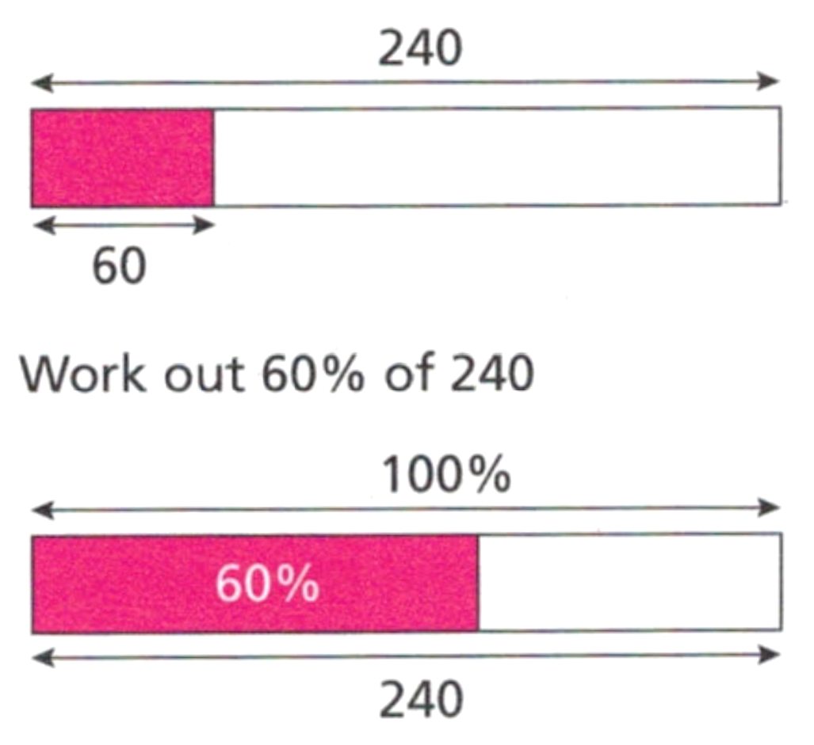  - Work out 60% of 240
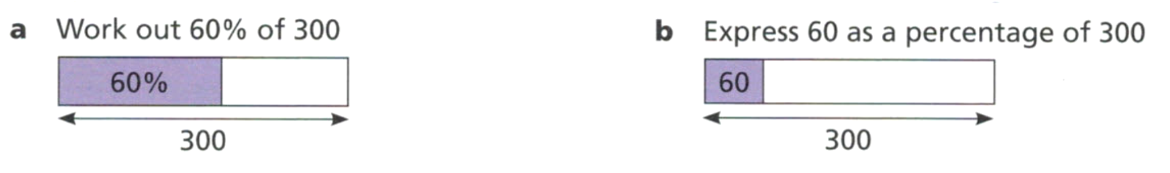  - Find 60% of 300 | - Express 60 as a percentage of 300

Development
- Express these quantities as percentages.
- 12 minutes out of  1 hour  20% | - 42 cm out of  1 m  42% | - 242 g out of  1 kg  24.2%
- 3 seconds out of  2 minutes  2.5% | - 750 kg out of  1 tonne  75% | - 60 cm out of  2 m  30%
- 18 hours out of  a day  75% | - 50 mm out of  1.5 m  $3.\dot{3}\%$ | - 700 mL out of  4.2 L  $16.\dot{6}\%$
- 5 g out of  200 g  2.5% | - 40c out of  $4  10% | - 10 km out of  200 km  5%
- 3 seconds out of  1 minute  5% | - 200 m out of  1 km  20% | - 100 mL out of  half a litre  20%
- 200c out of  $1  200% | - 45 marks out of  60 marks  75% | - 40 minutes out of  3 hours.  $22.\dot{2}\%$

- Harriet has $40 and Tamsin has $50.  Express Harriet’s money as a percentage of Tamsin’s  80% | - Harriet has $40 and Tamsin has $50.  Express Tamsin’s money as a percentage of Harriet’s  125%
- Harriet has saved $40 out of a $50 goal. What percentage does she still need?  20% | - Tamsin has written 400 words out of a 500 word essay. How much does she still need to write, as a percentage?  20%

Mastery
- Emily does a 2 part test. She scores 19 out of 30 in Section A and 45 out of 55 in Section B.
  - What percentage did she score in Section A?

$63.\dot{3}\%$
  - What percentage did she score in Section B?

$81.\overline{81}\%$
  - What percentage was her overall mark out of 85?

$75.29\%$
- In a science experiment, 40g of Chemical A is mixed with 85g of Chemical B.
Jimmy calculated the percentage of Chemical A in the mixture as 47.06%
Explain why he is incorrect.

Jimmy did $\frac{40}{85}$ when it should be $\frac{40}{125}$

- A standard flag is a rectangle 114 cm long by 56 cm wide.
  - What is the area of a standard flag?
6384 cm²
  - Calculate the percentage of the flag that each of these shapes take up.
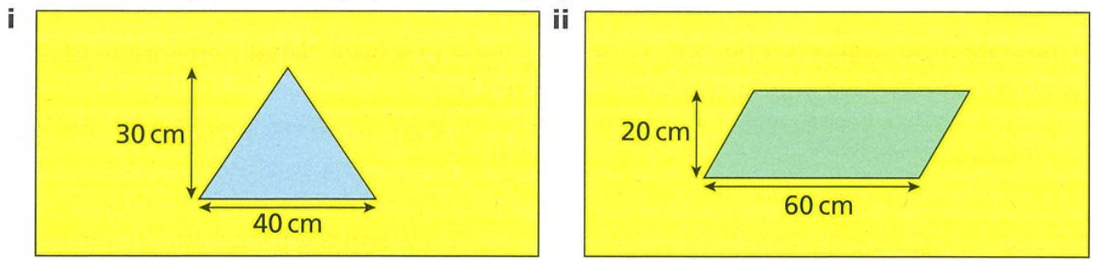  9.4% | 18.8%
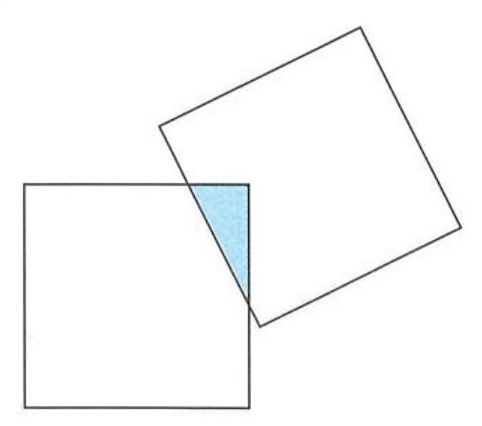
- The diagram shows two identical squares overlapping. 15% of each square is shaded.
What percentage of the whole diagram is shaded?

$$\frac{15}{185}×100=8.\overline{108}\%$$

Percentage Change

- Review
- Express a quantity as a percentage of another.
- 50 as a percentage of 40 | - 40 as a percentage of 50
- A painting appreciated in price from $500 to $600. What is the new price as a percentage of the original? | - A shirt was discounted from $80 to $35. What is the discounted price as a percentage of the original?

- Calculate change using $Change=Final-Original$
- Original: 120  Final: 150 | - Final: 70  Original: 80
- Original: 120  Final: 95 | - Final: 200  Original: 72

- Identify increase or decrease from sign
- Change = $+30$ means (circle):  increase | decrease | - Change = $-30$ means (circle):  increase | decrease

- Percentage Change
Percentage change expresses the change as a percentage of the original.
1. Calculate the change by identifying the final and original amount.
$$Change=Final-Original$$
2. Calculate the percentage change.
$$\% change=\frac{Change}{Original}×100 \\ =\frac{Final-Original}{Original}×100$$
- Percentage change is positive for increase, and negative for decrease.

- Example Calculate percentage change
A quantity changes from 120 to 150. Find the percentage change.
Original Final
1. Change $=150-120$  $$=30$$  2. $\%$ change $=$ $\frac{30}{120}$ $×100$  $$=25\%$$ | We did $150-120$ instead of the other way around because change = ………………… $-$ ………………  We divide by $120$ because percentage change is always calculated as a percentage of the ………………… amount.

- Guided Practice
- A quantity changes from 80 to 120.  Find the percentage change.  1. Change =  2. | - A quantity changes from 80 to 70.  Find the percentage change.
- The population of a town changed from 8500 to 9350. Find the percentage change. | - A price of a dress is now $36.  It used to be $45. Find the percentage change.

- Key Ideas
- Change = …………… $-$ ……………
- Percentage change is the change divided by the …………………, then multiplied by 100.

Foundation
- Complete the table, showing percentage change.
Original Amount | New Amount | Change | Percentage Change
120 | 150 | $$150-120=30$$ | $$\frac{30}{120}×100=$$  25% increase
12 | 20 |  | $66.6\dot{6}\%$ increase
140 | 70 |  | 50% decrease
80 | 15 |  | 81.25% decrease
120 | 270 |  | 125% increase

- Last year, a tennis club had 150 members. This year, the tennis club has only 126 members.
  - How many fewer members does the club have than last year?

24
  - Work out the percentage reduction in the number of members.

16% decrease
- Last year, a book club had 60 members. This year, the book club has 96 members,
  - How many more members does the club have this year than last year?

36
  - Work out the percentage increase in the number of members.

60% increase
- A plant is 1.6 m tall. One month later, the plant is 2 m tall.
Find the percentage increase in the height of the plant.
25% increase
- Find the percentage change (increase or decrease) when:
- 15 g becomes 18 g  20% increase | - 18 g becomes 15 g  $16.\dot{6}\%$ decrease
- 4 m becomes 24 m  500% increase | - 24 m becomes 4 m  $83.3\dot{3}\%$ decrease

Development
- Find the percentage change, to two decimal places, when:
- A ticket was $60 but changed to $29.  $51.6\dot{6}\%$ decrease | - A ticket of $60 originally cost $29.  106.90% increase
- A 12 cm tall hedge grows to 18 cm.  $50\%$ increase | - A hedge that got cut down to 12 cm was originally 18 cm.  $33.3\dot{3}\%$ decrease

- Find the percentage change when:
- $12 is increased to $15.  25% increase | - $12 is increased by $15.  125% increase
  - What is the difference between “increased to” and “increased by”.

“increased to” tells you the final value;
“increased by” tells you the change.
- Find the percentage change when:
- $60 is decreased by $15.  25% decrease | - $60 is decreased to $15.  75% decrease
- $25 is increased to $37.  48% increase | - $25 is increased by $37.  148% increase
- $55 is decreased to $18.  67.27% decrease | - $37 is increased to $58.  56.76% increase

- A rugby player has mass 105 kg. His doctor advises him to lose 15% of his mass.
  - Work out the mass of the rugby player if he succeeds in losing 15% of his mass.
89.25 kg
  - The rugby player actually loses 12 kg. What percentage of his mass has he lost?

11.43% decrease

Mastery
- Perform these percentage operations.
- Find 35% of 60  21 | - Find 160% of 35  56
- Find 60% of 35  21 | - Increase 35 by 160%  91
- Increase 60 by 35%  81 | - Decrease 60 by 35%  39
- Increase 35 by 60%  56 | - Decrease 35 by 60%  14
- What is 100% of 35?  35 | - Decrease 35 by 100%  0
- Increase 35 by 100%  70 | - 35 as a percentage of 60  58.3%
- Find 160% of 35  56 | - 60 as a percentage of 35  171.43%

- Find the percentage change, round to 1 d.p.
- 35 changed to 60.  What is the percentage change?  71.4% increase | - 60 changed to 35.  What is the percentage change?  41.7% decrease
- 60 increased by 35.  What is the percentage change?  58.3% increase | - 35 increased by 60.  What is the percentage change?  171.43% increase

Financial Applications of Percentage Change

- Review
- Calculate percentage change
- 50 to 70 | - 100 to 80

- Vocabulary for Percentage Change
Cost price: The amount a seller pays for an item.
Selling price: The amount a seller charges for an item.
Profit/Loss = Selling Price − Cost Price
If positive → Profit If negative → Loss

- Identify Cost price and selling price
What a seller pays for an item is called the ………………
What a seller charges for an item is called the ………………
Selling price is what a seller ………………… for an item.
Cost price is what a seller ………………… for an item.
Identify the cost price and selling price, then the profit or loss.
- Amy buys a table for $300 and sells it for $400. | - Olivia buys a table for $400 and sells it for $300.
- Lottie buys a phone for $1200 and sells it for $800. | - Charlotte sells a phone for $1200, having bought it for $800.
- Jemma purchases stock for $250 and retails it for $300. | - Cate sells some trading cards for $500. She bought them for $900.
- Calculating Percentage Profit and Loss
1. Calculate the profit/loss by identifying the final and original amount.
$$Profit/Loss=Selling Price-Cost Price$$
2. Calculate the percentage Proft/Loss.
$$\% Profit/Loss=\frac{Profit/Loss}{Cost Price}×100 \\ =\frac{Selling Price-Cost Price}{Cost Price}×100$$
The answer is positive for profit, and negative for loss.

- Example Calculate percentage profit/loss
A collector buys an antique for $250 and sells it for $300. Calculate the percentage profit/loss.
1. Profit/Loss $=\$300-\$250$  $=\$50$ profit  2. % profit $=$ $\frac{50}{250}$ $×100$  $=20\%$ profit | The cost price is ……………  The selling price is ……………  We know it is profit because the answer is ………………  We divide by the ……………… price because it is the original amount.

- Guided Practice
- A trader buys goods for $80 and sells them for $100. Calculate the percentage profit/loss.  1. Profit/loss =  2. | - Roxy buys a concert ticket for $125 and sells it for $75. Calculate the percentage profit/loss.
- A car dealer buys a vehicle for $15,000 and sells it for $18,000. Calculate the percentage profit/loss. | - An investor buys shares for $8,000 and sells them for $6,300. Calculate the percentage profit/loss.

- Key Ideas
- Percentage profit or loss is calculated as a percentage of the ………………… price

Foundation
- Calculate the percentage change and state whether it is a profit or loss.
- $20 becomes $36  80% profit | - $10 becomes $13  30% profit
- $40 becomes $30  25% loss | - $25 becomes $21  16% loss

- Sven buys a tablet computer for $650. How much does he sell the tablet for if:
- he makes a profit of 20%.  $780 | - he makes a loss of 30%.  $455

- Abdullah buys a scooter for $75. He later sells it for $60
- What loss does Abdullah make on the scooter?  $15 | - What percentage loss does he make?  20% loss

- A shop buys printers for $80 and sells them for $95.
- How much profit does the shop make for each printer?  $15 | - What percentage profit does the shop make for each printer?  18.75% profit

- Complete the table.
Cost Price $ | Selling Price $ | Profit/Loss | % Profit/Loss
4 | 5 | $1 profit | $$\frac{1}{4}×100=25\% profit$$
10 | 12 |  | 20% profit
10 | 7 |  | 30% loss
16 | 12 |  | 25% loss
24 | 30 |  | 25% profit
100 | 127 |  | 27% profit
50 | 47 |  | 6% loss
25 | 15 |  | 40% loss

Development

- Gari buys a ticket to a concert for $90. She sells it to her friend for $72. Calculate the percentage loss she made.  20% loss | - Mr Ding buys trading cards for $120.  10 years later he sells them for $500. Calculate the percentage profit made.  $316.\dot{6}$% profit
- Ava buys scarves for $15 and sells them for $21.  What is her percentage profit?  40% profit | - Beth buys a car for $8000.  Two years later, she sells it for $5500.  Work out her percentage loss.  31.25% loss

- Which of the following stores is offering a larger percentage discount?
Store A: Jeans originally selling for $60, now on sale for $51
Store B: Jeans originally selling for $84, now on sale for $73.50

Store B
- Chloe is running a tuck shop. She buys a pack of 12 chocolate bars for $3.50
  - Chloe sells all the chocolate bars for 60c each. Work out her percentage profit.

105.71% profit
  - Work out Chloe's percentage profit if she sells one third of the chocolate bars for 60c each and the rest for 30c each.

37.14% profit

  - A new car costs $15000. After 3 years, the car has lost 35% of its value.
How much is the car worth after 3 years?

$9750
  - A different car costs $18000 when new and is worth $14000 after 3 years.
What is the percentage decrease in the value of the car?

$22.\dot{2}$% decrease

- Complete the table. Round your answer to 2 decimal points.
Price Paid | Selling Price | Percentage Profit or Loss
$16 | $20 | $$\frac{Change}{Original}×100=$$  25% profit
$20 | $16 | 20% loss
$5.99 | $7.49 | 25.04% profit
$30 | $$30×1.45=$$  $43.50 | 45% profit
$30 | $34.50 | 15% profit
$80 | $68 | 15% loss
$85 | $17 | 80% loss
$90 | $166.50 | 85% profit
- Decide whether you are finding the selling price or calculating the percentage change.
- Xavier purchased materials for $48 and made a dog kennel.  Later, he sold the kennel for $84. Calculate the percentage profit or loss.  75% profit | - Jemma purchased a $400 foal.  How much should she sell it for if she wants to make a 30% profit?  $520
- Lee purchased a $5000 car, which she later sold for $2800.  Calculate the percentage profit or loss.  44% loss | - Estelle purchased a piece of sporting equipment for $120.  She sold it for a loss of 35%. How much did she sell it for?  $78
- Helen creates bracelets using materials costing $0.80 and sell them for $10 each. Calculate the percentage profit or loss.  1150% profit | - Charlotte wants to sell her knitted squares for a 250% profit.  If the squares cost her $1.30 to make in materials, how much should she sell them for?  $4.55

Mastery
- Compare these two investments:
Investment A: Cost $500, sold for $650
Investment B: Cost $800, sold for $1000
Which made the higher percentage profit?

A: 30%; B: 25%.
Investment A has higher percentage profit.

- A car dealer buys a car for $12,000 and sells it for $15,600.
  - Calculate the percentage profit.

30%
  - What selling price would give a 40% profit?

$$12000×1.4=\$16800$$
- A retailer buys T-shirts for $8 each and sells them for $14.
  - Calculate the percentage profit.

75%
  - How much profit is made from selling 50 T-shirts?

$300
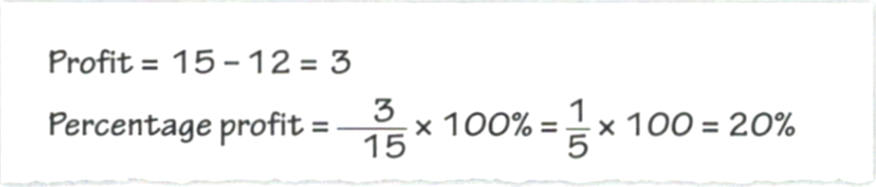
- Seb buys a book for $12 and sells it for $15. He works out his percentage profit:

Explain Seb’s mistake.

He divided by the new value instead of the original value.
- Jason and Cheryl’s test marks both go up by 20 percentage points.
Jason: “My test mark went up from 55% to 75%”
Cheryl: “My test mark went up from 42% to 62%”
Who has made the most improvement? Explain your answer.

Cheryl, as she made a 47.6% improvement while Jason made a 36.4% improvement.
- Flo buys 12 cupcakes for $5.64. She sells the cupcakes for 60 cents each.
Work out Flo's percentage profit.

27.66% profit
- Emily buys 6 mugs for $17.10. She sells each mug for $3.55. Work out her percentage profit.

24.56% profit
- An elephant calf weighed 115 kg when born. The calf grew to an adult weighing 5.93 tonnes. Calculate the percentage change in mass, to the nearest percentage.

5057% increase
- Emma completed a worksheet in 2:18 (minutes:seconds).
A week later, she completed the same worksheet in 1:45.
Work out the percentage change, to 1 d.p.

23.9% decrease
- Chloe buys 200 bracelets for $120.
At the summer fete, she sells one-quarter of the bracelets for $2.
She then reduces the price of the remaining bracelets by 25%.
At the end of the day, she has 20 bracelets left. Work out:
  - the number of bracelets that she sold at the reduced price.
130
  - Chloe's total income.

$295
  - the percentage profit that she made.

$45.8\dot{3}$% profit

